Students should be familiar with different measuring instruments.(Use) (PW1)

Know what these instruments are used for. (PW1)

Know how these instruments work. (PW1)

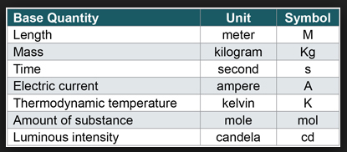

Many different instruments are used to measure Length
They include:

A ruler: Short lengths
Ex:The length of a copy.
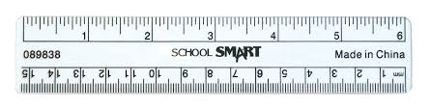

A trundle wheel: Longer lengths that are not straight. Ex: A path.
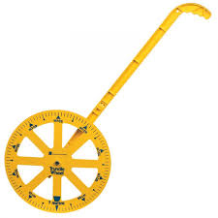

A Opisometer: Measures short curving lines.
Ex: A line on a map.

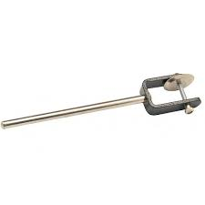

A Vernier Calipers: Measures Thin items accurately.
Ex: The width of a coin.
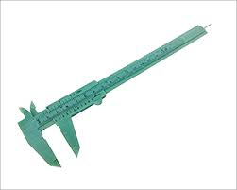

A Micrometer: Measures very thin items accurately.
Ex: The width of a thin electrical wire.
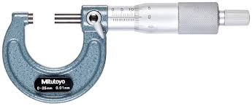

We use an Electronic Balance to measure the mass of substances in Kilograms.
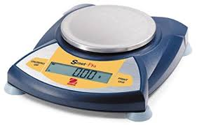

Stopwatches and timers are used to measure time when carrying out an experiment.
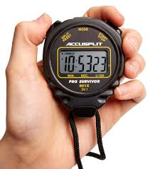

Students should be able to identify and measure/calculate.

(1st Year) Length – Mass –Area – Volume – Density.

(2nd Year) Time – Speed – Acceleration – Force.

(3rd Year) Potential difference – Current – Resistance – Electrical Power. (See electricity)

Above are all (PW2)

As stated previously many different instruments can be used to measure length. Can you remember their names and what lengths they are most suited to measuring?

Area.
The area of regular shapes can be found using formulae.
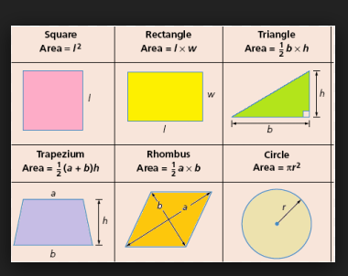

The area of irregular shaped objects can be found using graph paper as shown below.

Find the area of your hand.

Look at the picture.

Your hand may cover 783 of the small squares on the graph paper.

Each square has an area of 1mm squared.
This means that your hand has an area of 783 square mm.
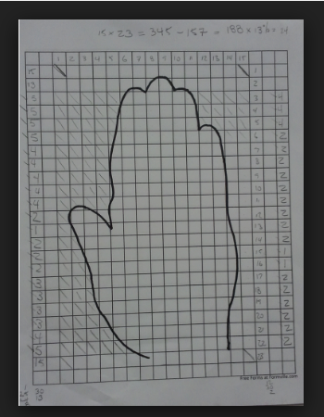

Volume

The
Volume of regular shaped objects can be found using formulae.
Ex:
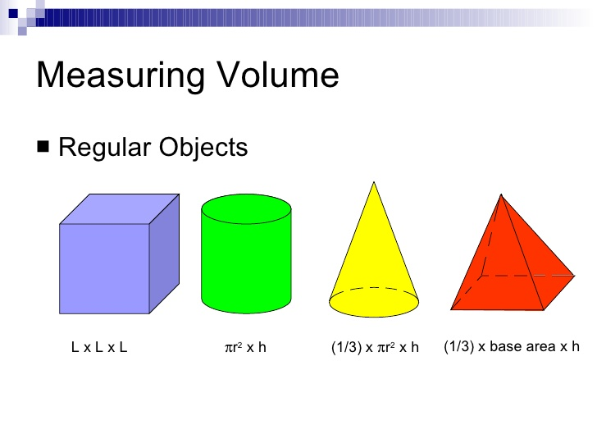
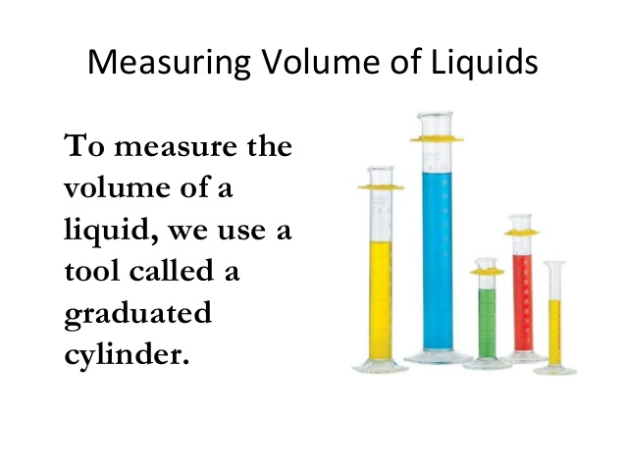
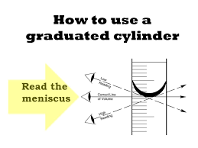
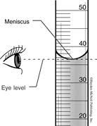

The level of liquid in a graduated cylinder should always be read at eye level and from the bottom of the meniscus.

How to measure the volume of an
irregular shaped object.

Take a graduated cylinder and half fill with water.
Read the volume of the water.
Place the irregular shaped object into the graduated cylinder.
Read the volume again.
The difference between the start volume and the end
volume is the volume of the irregular shaped object.
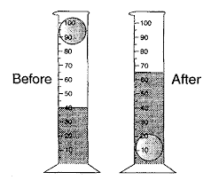

Sometimes if the object is particularly large we can use an
overflow can and collect the water displaced by our object.
The collected water is the volume of our object.
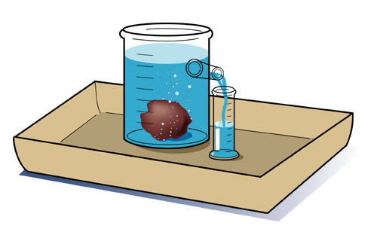

Finding the mass of any object.
We use an electronic balance.
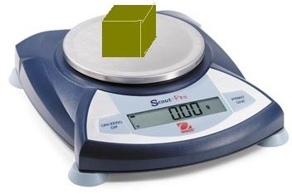
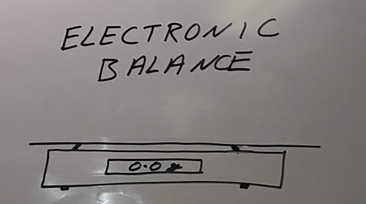

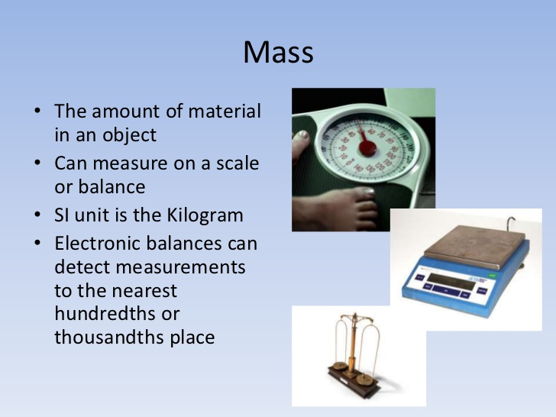

Density
The density of an object is the mass per cubic cm
of that material.

Formula: Density = Mass / Volume
Unit = g/cm³ |  | Or |  | Kg/m³

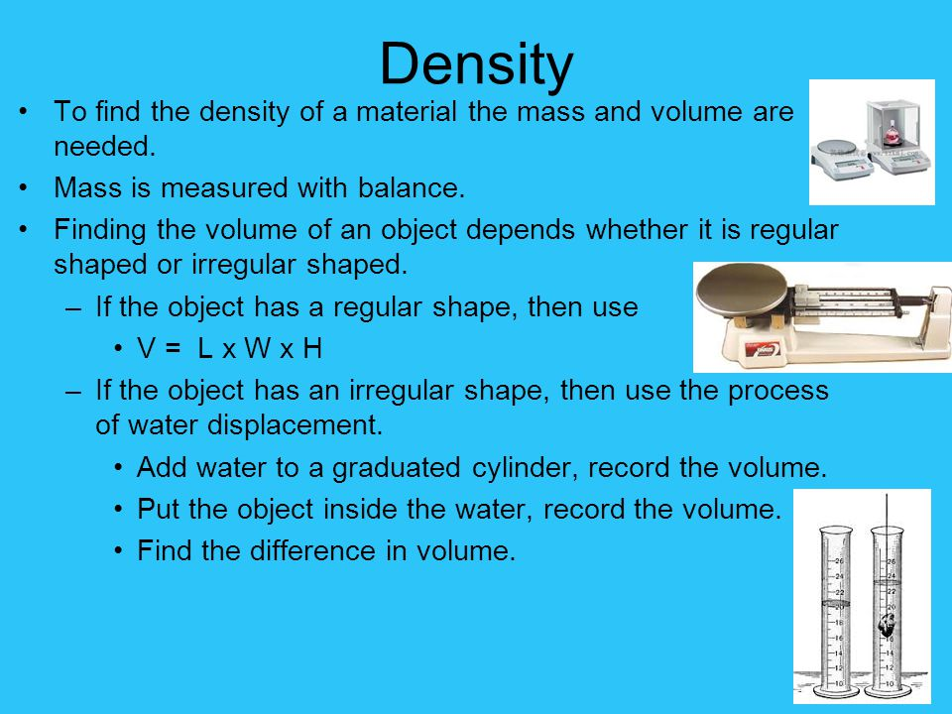

Speed Velocity Acceleration & Force:

<<Speed and Velocity use 1st.pptx>>

<<Acceration and graphs use 2nd.pps>>

<<Speed velocity and acceleration worksheet.docx>>

<<vel & acc alternative ppt.pptx>>

Be able to investigate patterns in physical observables. (PW3)

Heat:
(CW6) = conduction: Important
In this section too.
<<Heat & state change explanation.pptx>>

<<Heat transfer use 1st.pptx>>

<<Heat And Expansion use 2nd.pptx>>

Light:
<<Light General.pptx>>

<<Light (stright lines).pptx>>

<<Reflection, refraction lenses examples.pptx>>

<<Light questions (Worksheet).docx>>

<<higher order questions 3 Light.docx>>
Sound:
<<Sound General.pptx>>
<<Sound questions & Answers.pptx>>

<<Sounds Experiments for physical observables.pptx>>

<<Sound and light Q sheet higher order questions.docx>>

Be able to discuss a technological application of physics.(How does it work?) (Research & Discuss) (PW4)

Be able to discuss the technical application in terms of:

Societal impact.(PW4)

Environmental impact.(PW4)

Cathode Ray Tube

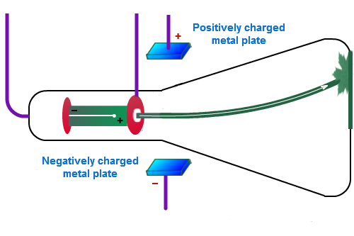

Operation:

- Low voltage is applied to a filament and this heats the cathode.
- Thermionic emission occurs at the cathode.
- There is high voltage between the cathode and the anode and this accelerates the electrons.
- The tube itself is a good vacuum and so accelerated electrons do not collide with gas particles (as there are none) and so pass unhindered to the screen.
- The kinetic energy of the accelerated electrons is changed to light.
- The point at which the electrons hit the screen is controlled by deflecting coils (deflecting plates).
- The plates are charged positively and negatively (electrons are negatively charged), so the beam direction can be controlled.

Applications of Cathode Ray tubes: TV, Computer monitors, Oscilloscope, Electrocardiogram.

Societal Impact:
- The invention of the CRT allowed moving pictures to be transmitted around the world.
- It has had a huge effect on culture throughout the globe.
- The movie industry.
- News with pictures travelled around the globe at great speed.
- Products could be advertised to people in their own homes.
- New medical devices which output information to the CRT were developed Ex: The electrocardiogram.
- Scientists could now represent wave forms visually on a screen.
- Computers could output information to screens.

Environmental Impact:
- TV screens collectively use a significant amount of electricity and therefore contribute to the production of greenhouse gasses.
- Incorrect disposal of old TV and computer screens can have negative environmental impact.
- Programs about conservation and protecting ecosystems and biodiversity can educate people and have a positive impact on the environment.

Students should be able to identify and measure/calculate.

(3rd Year) Potential difference – Current – Resistance – Electrical Power. (PW2)

(3rd Year) The students should be able to design and build simple circuits.(PW5)

(2nd Year) Students should be able to investigate the conductivity of materials (Also from chemistry section) (CW6).

(2nd Year) Students should be able to design build and test a device that transforms energy from one form to another while performing a function. Be able to describe these energy changes and ways to improve efficiency.(PW7)

<<Static and Current Electricity.pptx>>

<<Uses and Effects of Electricity.pptx>>

video circuit parts and symbols circa 1.5 minutes

Below is the experimental set up for testing if materials can conduct electricity.
When the sample is placed in the gap with the crocodile clips:

The material is a conductor if the bulb lights.
The material is not a conductor is the bulb fails to light
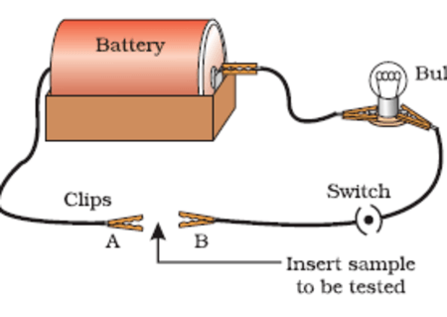

Below is the set up for testing if a solution can conduct electricity.
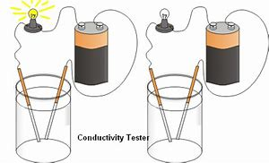

One of the beakers above contains tap water while the other contains salt water.
Which one is which?
Explain your answer.

Building a device which converts energy and preforms a function.
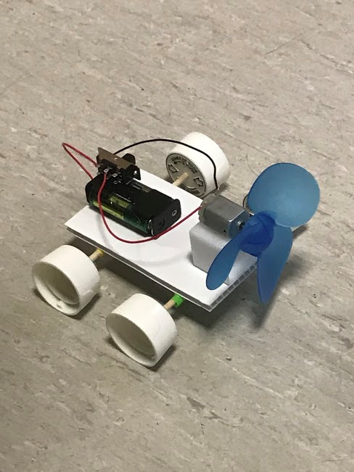
Assignment:
(1) Build a light weight free moving trolley at home from everyday items.
(2) Ensure your design allows for a battery and a fan to be mounted onto it.
(3) Bring you design into class and race your design against the designs of other students.

Explanation of energy conversions:
(1) The battery contains Chemical potential energy.
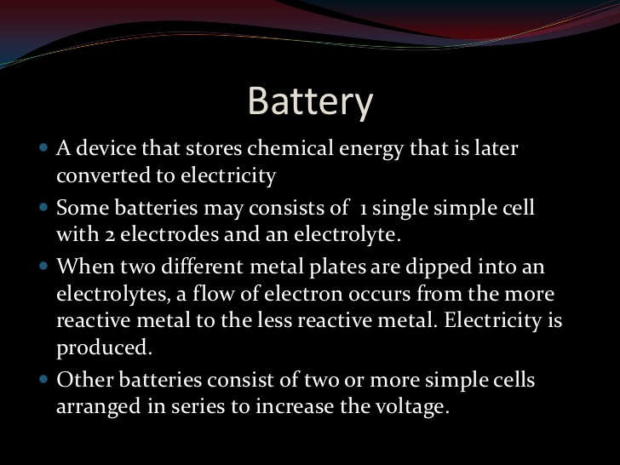

(2) The Electrical energy is then converted into Kinetic (Mechanical) energy in the Motor.
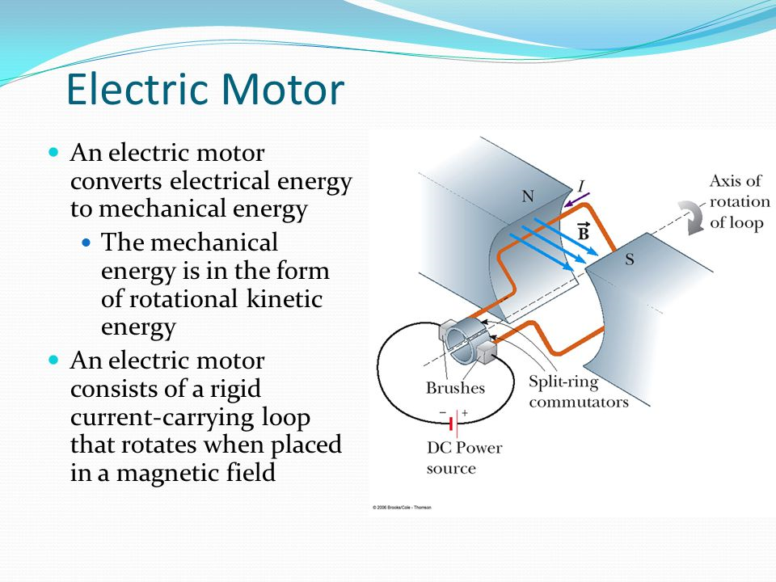

(3) The motor turns a fan which creates a force called thrust by forcing air past the blades.
When the force of thrust (The force trying to move the car)
exceeds the forces of friction (the forces keeping the car from moving) the car will start to move.

How could we improve the performance of our car?
  - What effect would oiling the wheels have?
  - What effect would giving the wheels more grip have?
  - What effect would adding a battery with higher voltage have?
  - What effect would increasing the fan size have?

Try to make these simple circuits in the lab: (PW5)

Video series and parallel circuits first 1.5 minutes & Ohm's law after

Circuit 1:
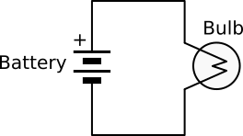Current flow video in series circuit

Circuit 2.
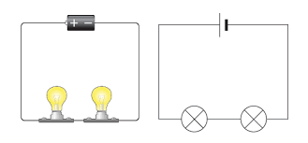Current flow video in parallel circuit

Circuit 3:
See what difference this makes to circuit 2.
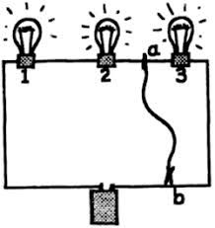

Circuit 4:
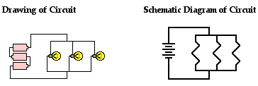

Graphene:

Video Introducing graphene circa 3.5 minutes

Home work:
Define graphene.
Give 3 properties of graphene.
Give three possible future uses of graphene.

