Nature of science
Students should know how scientists work and how ideas are modified over time (NoS1)

What is science? Science is the study of the world around us.

Scientific Method: A series of steps that scientists follow to investigate occurrences that can be tested.

Hypothesis: An idea that will be tested by the investigation.

Theories explain and predict natural Phenomena.

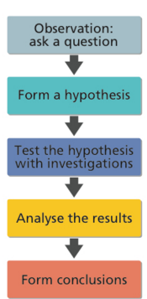

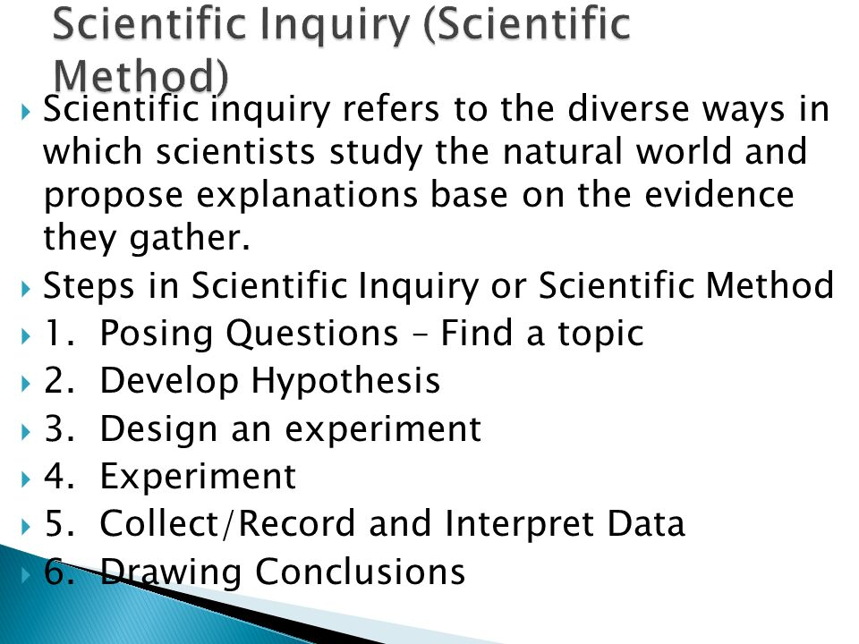

Students should be able to recognise questions that can be tested scientifically (KoS2)

Be able to pose testable hypothesis. (KoS2)

Compare strategies for testing hypothesis (Evaluate) (KoS2)

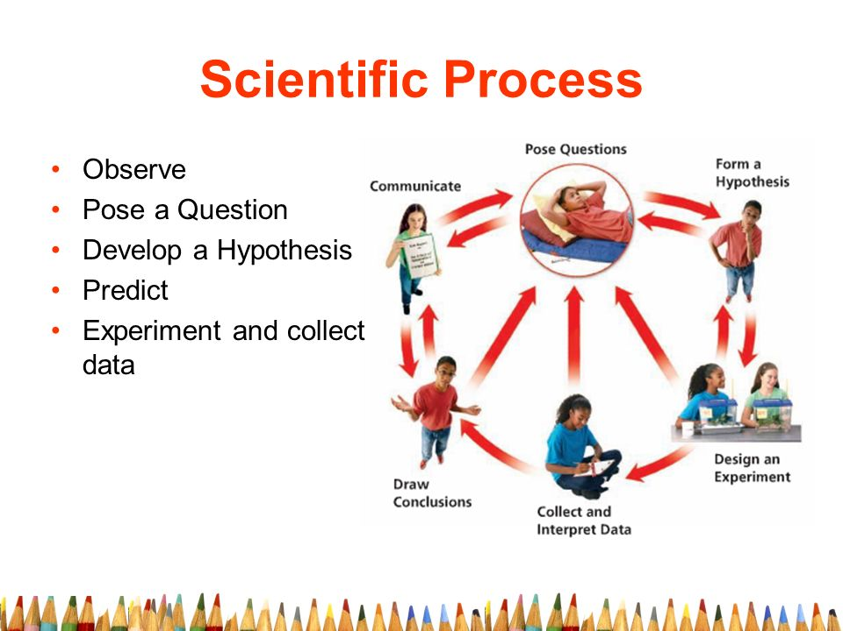
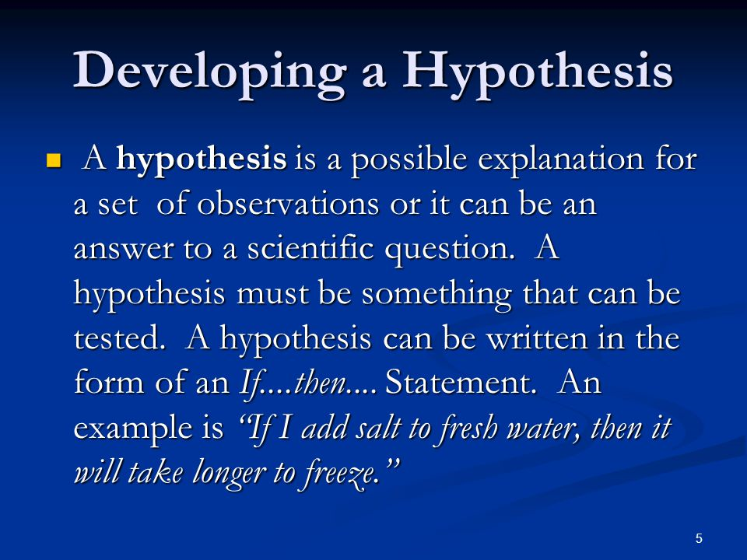

Or you could go a step further with your hypothesis development:
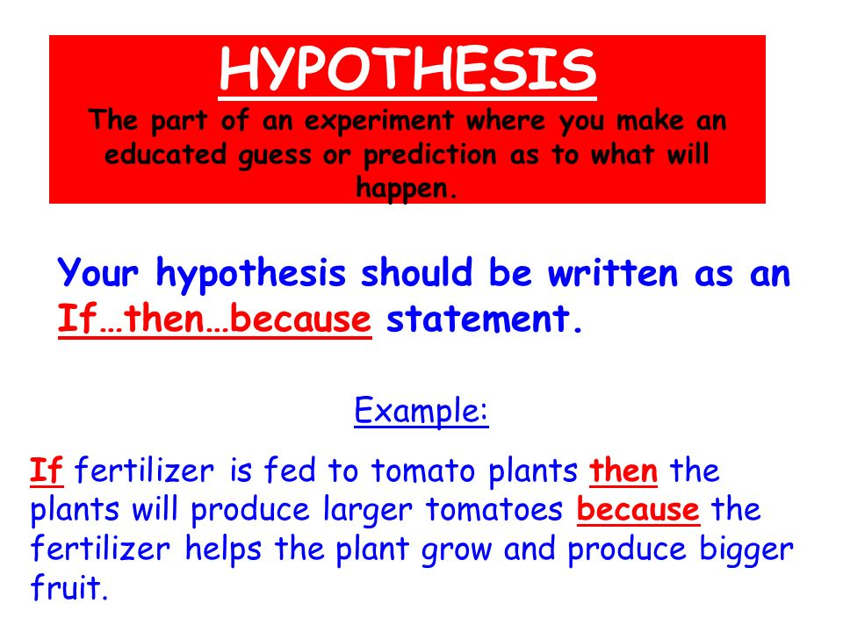

Students should be able to design, plan and conduct investigations (KoS3)

Consider and explain reliability, accuracy, precision, fairness, safety and ethics with regard to investigations. (KoS3).

When using the scientific method there is a particular approach we should take when carrying out and investigation.

The order is as follows:

Title question.
Hypothesis.
Apparatus / equipment needed.
Safety precautions.
Variables identified.
Procedure/ method.
Results.
Conclusions.
Improvements.

Let's look at each of the items on the list in more detail.

Title question:
This is the question that has been asked and you usually form your hypothesis from this.

Example: "Does fertilizer make plants grow taller?"
Or : "What are the effects of coloured light on plant growth?"

Hypothesis:
As we saw in the previous section, We look at the title question and form our hypothesis from this.
For the examples above you can use "if" & "then" statements to effectively form a hypothesis.
So for:
"Does fertilizer make plants grow taller"
We could say
"If fertilizer is added to plants then they will grow taller.
And for:
"What are the effects of coloured light on plant growth"
We could say
"If green light is incident on a plant then it will grow taller"

Apparatus:
List and Gather the equipment needed to carry out your investigation.

Safety precautions
Safety :
Before an investigation we must carry out a risk assessment.

We should:
- Outline the hazards of carrying out your investigation
- List the steps in order to avoid these hazards.
- Identify the person responsible for minimising these hazards.

Ethics: the need to carry out investigations and give results in a responsible way.

Variables
Variables: A factor that can be changed measured or controlled in an investigation.

Three types
- Independent variable = Variable you can change
- Dependent variable = Changes as a result of changing the independent variable.
- Controlled (Fixed) Variable = All other variables that are kept the same.

A control is a copy of an investigation, where every factor is the same except the factor being investigated (independent variable)

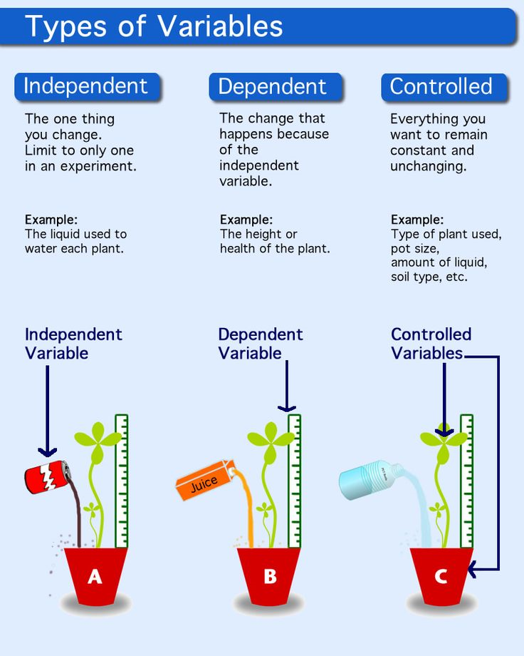

<<Lesson 1.Variables.2010.ppt>>

Drawing scientific diagram

When collecting data it is important to arrange the information in a structured order.
As the dependent variable changes these will be your results.
When dealing with numbers we can arrange them from the lowest to the highest.
Arranging the data in this way gives us the range of the data.

There are two general types of data.
Quantitative data is information about quantities; that is, information that
can be measured and written down with numbers.
Some examples of quantitative data are
your height, your shoe size, and the length of your fingernails.

Qualitative data is information about qualities;
information that can't actually be measured.
Some examples of qualitative data are the softness of
your skin, the grace with which you run, and the color of your eyes.

Here's a quick look at the difference between qualitative and quantitative data.
- The age of your car. (Quantitative.)
- The number of hairs on your knuckle. (Quantitative.)
- The softness of a cat. (Qualitative.)
- The color of the sky. (Qualitative.)
- The number of cent in your pocket. (Quantitative.)
Remember, if we're measuring a quantity, we're making a statement about
quantitative data.
If we're describing qualities, we're making a statement about qualitative data.

Recording Data
When collecting data we should use a results table which will allow us to record
the information clearly

When drawing a graph you should
- Always put the quantity that you control on the X axis
- Decide on a suitable scale for each axis.
- Label the X & Y axis and include the correct units.
- Plot the points.
- Include a Title.
- You may have to add a line of best fit or a trend line so as to see
your results more clearly.

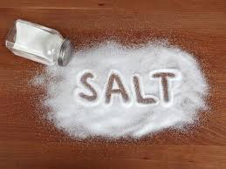

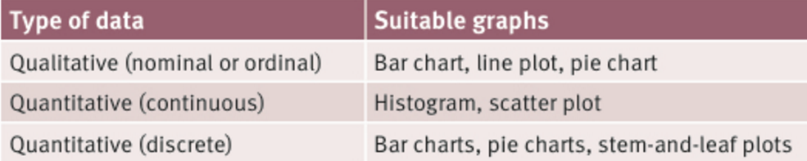

Different types of graphs are used to represent different types of data
A Bar chart , Line Plot or Pie Chart are used to show Qualitative data either Nominal or Ordinal
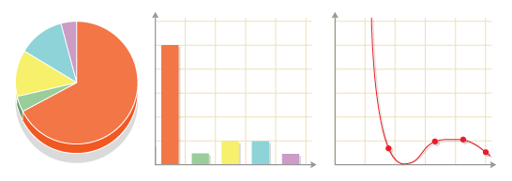
A Histogram or a scatter plot are used to show Quantitative (Continuous) data
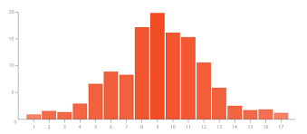
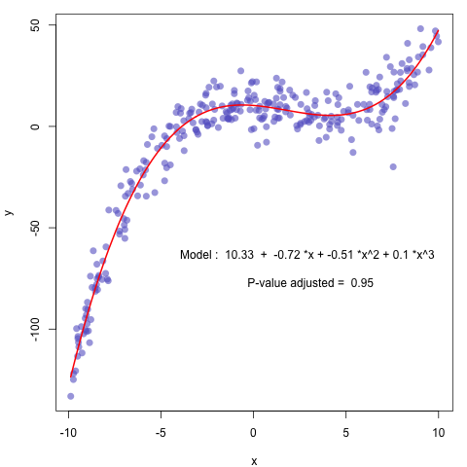
Bar Charts, Pie Charts, Stem-and-leaf Plots are used to show Quantitative (discrete) data
