Students should be able to investigate if mass is unchanged when chemical and physical changes occur. (CW1)

Account for Conservation of mass, state change, physical & chemical changes. (CW2)

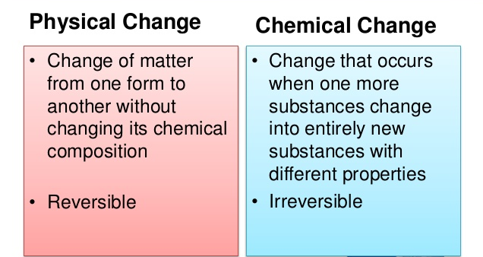

Video Physical & chemical changes explained circa 5.5 minutes

<<Solids, Liquids and Gases.pptx>>

Investigation:
To see if mass is conserved after ice under goes a Physical change to water:
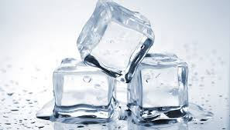
Take an ice cube and find its mass using an electronic balance:
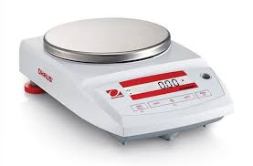
Allow the ice to melt in a container of known mass:
(You can use the zero facility on the electronic balance)
Find the mass of the melted ice cube (ie) The water.

What is your result?

If A substance changes state from a solid to a liquid or a gas, this is a physical change and NO change in mass occurs.

Making a solution is another way of producing a physical change.
<<Solutions Explained.pptx>>

Referring to the investigation above can you design an experiment to show that mass is conserved when making a solution?

…...............Chemical Change..............

It is also true that:
In a chemical reaction mass is conserved.

Investigation:
Consider the following chemical reaction:

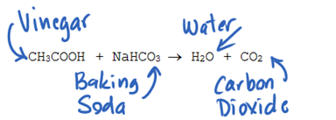

Adding Baking soda to Vinegar (The reactants)

Produces a chemical reaction and two different products are left.

In this case Water & Carbon dioxide.

In The Lab:

Baking soda is put into a balloon.
Vinegar is put into a conical flask.
Their combined mass is found using an electronic balance.
The two chemical are allowed to mix a shown below.
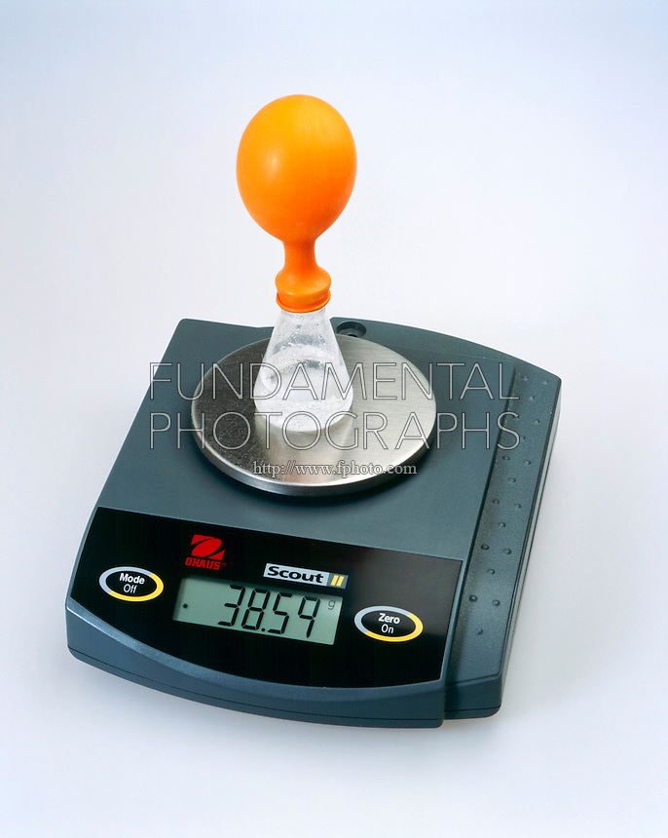
The reaction is a chemical one.
Baking soda and Vinegar are changed into water and C02.

Even though the substances have been completely changed chemically:
The mass of the reactants = The mass of the products

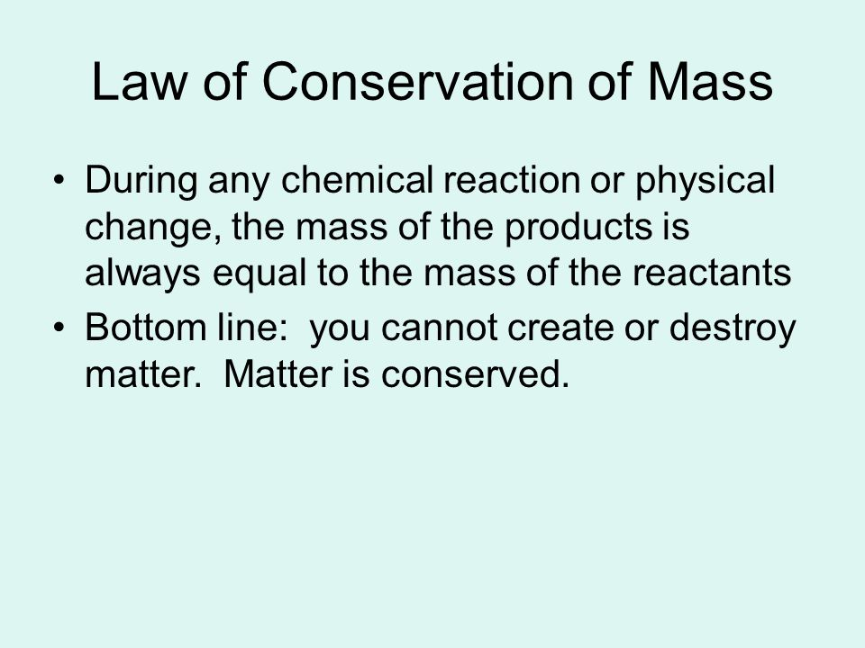

Students should know the subatomic particles. (Describe) (CW3)

The Bohr model (Describe) (CW3)

Electronic configuration.(Describe) (CW3)

Comparing mass and charge. (Describe) (CW3)

(Develop & use models to Describe above areas) (CW3)

<<The Atom.pptx>>

Students should be familiar with separation techniques. (Provide a simple way to account for) (CW2)

<<Separating Mixtures.pptx>>

Students should be able to classify elements, compounds, mixtures, metals, non metals, solids, liquids, gases & solutions. (Classify) (CW4)

CW6 & solubility covered through making crystals

<<Elements, Compounds and Mixtures.pptx>>

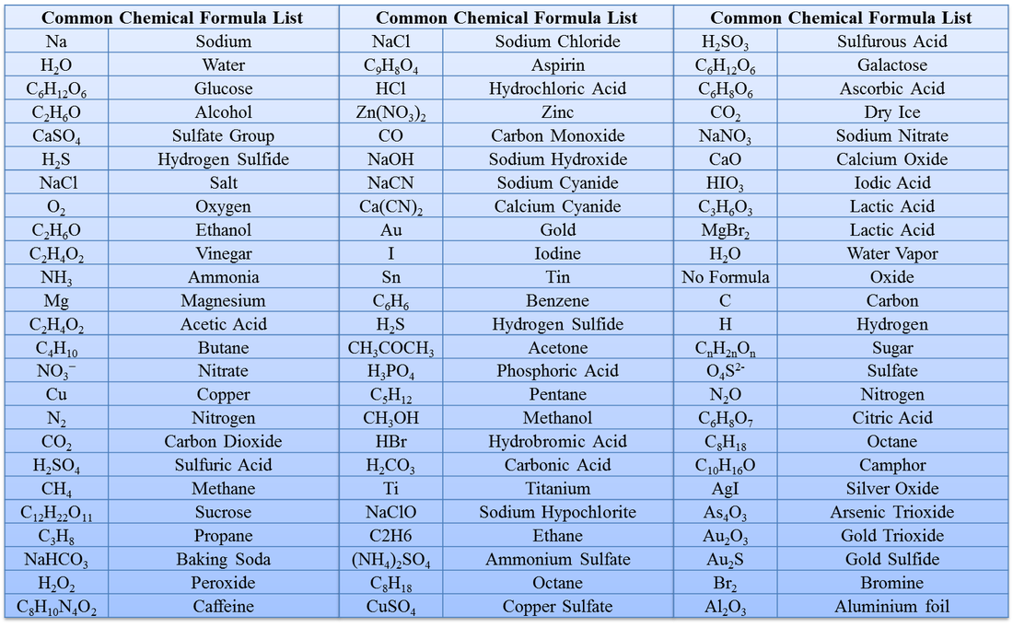

CW6 & solubility addressed here

Students should be able to use the periodic table to predict the ratios of atoms in two element compounds.(Use) (CW5)

<<periodic diagram.pptx>>

<<geography of periodic table.pptx>>

<<Bonding.pptx>>
<<Ionic and covalent bonds and compounds worksheet.docx>>

Students should be able to investigate the boiling point and melting points of materials.(Investigate) (CW6)*

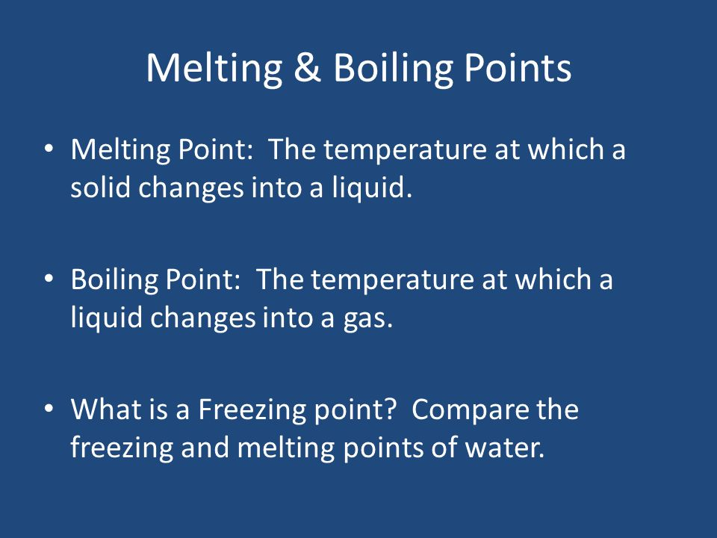

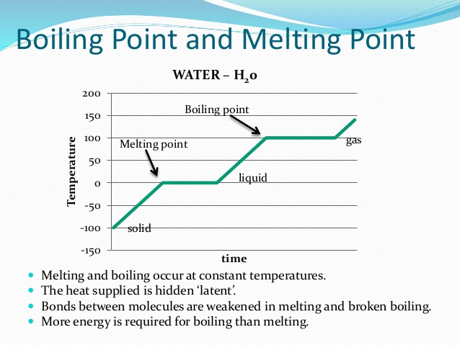

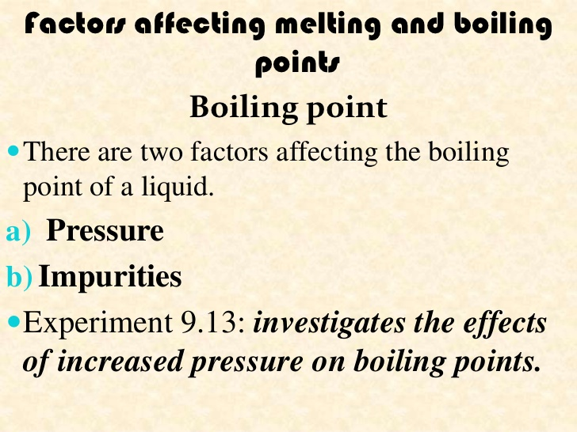
Exp 9.13.
Suck up a small amount of water at 90 degrees into a syringe
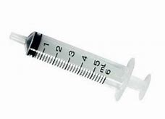
It can be seen that this water is not boiling.

Seal the end of the syringe and then reduce the pressure inside the it by pulling the plunger outward.
The water in the syringe begins to boil again at this reduced pressure.
Video of boiling point reduction experiment circa 50 seconds

Latent Heat: Is the heat a substance absorbs or gives out during a state change.
- There is no temperature change during a state change even though large amounts of heat may need to be added or removed.
- For example Ice changes to water.
- We can have ice at zero degrees and water at zero degrees.
- If we are heating the ice in order to cause it to change state (melt) the heat energy we add does not cause a temperature change.
- The energy is used to change the solid (ice) to a liquid (water)

Investigate the Melting point and the boiling point of water in the lab.

Should know about acid and bases and their reactions. (Investigate) (CW8)

Be able to use indicators and the Ph scale.(Use) (CW8)

Students should be able to consider reactions as being Endothermic or Exothermic. (Consider) (CW9)

Consider activation energy. (Consider) (CW9)

Consider simple profile diagrams. (Use) (CW9)

Investigate the effect of a number of variables on rates of reaction & gas production & biochemical reactions. (Investigate) (CW7)

Reactants = The substances that go into a chemical reaction.

Products = The substances that are left after a chemical reaction has taken place.

Ex: Coal + Oxygen -----> Ash + Carbon Dioxide + Water.
Reactants Products

Activation energy = This is the energy that must be added at first in order to start a chemical reaction.

Ex: When we strike a match we are supplying the energy needed to start a chemical reaction at the head of the match.

The chemical reaction at the head of the match (which is very hot) supplies the energy needed to light the wood of the match and allow the burning to continue.

In the above example we can see where activation energy was added twice in order to start a reaction.

Exothermic reaction = A chemical reaction in which heat is given out to the surroundings. The temperature of the surroundings increases.
Ex: A piece of coal burning in oxygen.

Endothermic reaction = A chemical reaction where heat is taken in from the surroundings. The temperature of the surroundings decreases.
Ex: Mixing baking soda and vinegar.

Energy profile diagrams for Exothermic & Endothermic reactions.
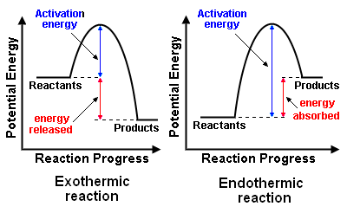

Signs that a chemical reaction is or has taken place.

- The surroundings heat up or cool down.
- There is a smell produced.
- Light is given out.
- Sound is produced.
- A gas is produced.

Factors that affect the rate of a chemical reaction.

- The surface area of the reactants.
- The temperature.
- The concentration of the reactants.
- A catalyst is present.

Catalyst: This is a substance which speeds up a chemical reaction without itself changing.

We will now investigate some of the factors that affect the rate of a chemical reaction.

(Don't forget we have already carried out an experiment to show that light intensity was a factor that influenced the rate of photosynthesis (a chemical reaction) in plants)

Surface Area:

Antacid Tablet Race
TOPIC: To see if surface area has any effect of the rate of a chemical reaction
Objective: To demonstrate how increasing the surface area of a chemical increases its reaction rate.
Description: A whole antacid tablet and a crushed tablet are added to separate beakers of water so that their relative reaction rates can be compared.
EDITED BY: Roger Storm, NASA Lewis Research Center
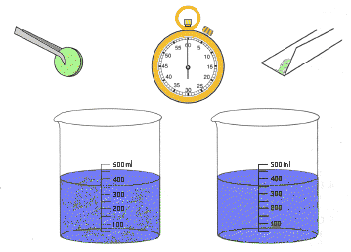

Materials:
- Antacid tablets (two per test)
- Two beakers (or glass or plastic jars)
- Tweezers or forceps
- Scrap paper
- Watch or clock with second hand
- Small block of wood

Procedure:
- Fill both beakers about half full with water of the same temperature.
- Wrap paper around one antacid tablet. Place the packet on a hard surface and crush the tablet by pressing on it with the wood block.
- Open the paper packet with the crushed tablet and hold it over one of the beakers. Pour the powder in the water and time how long it takes for the powder to dissolve.
- Pick up a whole tablet and drop it into the second beaker of water. Time how long it takes to dissolve completely
Discuss your results and from conclusions

The presence of a CATALYST can also effect
the rate of a chemical reaction:

Production of Oxygen gas using a catalyst in the Lab.

Video to prepare oxygen in the lab (catalyst) circa 6.5 minutes

