Checklist for Career Investigation
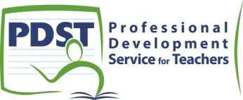

Ensure you can tick each statement before you hand up your Career Investigation for correction. If any statement cannot be ticked, make the necessary changes.
Did you proof read your Career Investigation?

Have you checked your word count to ensure it is between 300 – 600 words?

Did you check for accuracy of presentation and layout?
(spelling, grammar, capital letters, punctuation, font, headings, tabulation, identication)

Have you included a title, naming the career you are investigating?

Have you described at least three duties involved in the career you investigated,
using sentences in each case?

Did you name (and explain) at least three skills required for this career?

Did you name (and explain) at least three qualities needed for this career?

Have you described the training needed to become qualified in this career?

For each pathway, have you stated the following:
Name of college and course title?
Length of the course?
Qualification you will achieve at the end of the training period?
Subjects you will study throughout the course?
CAO points/subject requirements for each course?

If one of your pathways is not through the CAO system, did you state
the entry requirements?

Did you carry out research to check your own aptitude for this career?

Did you engage in any out-of-school activity?
(such as interviewing a person in this career area/work shadowing/work
experience, that shows you are aware of the aptitudes/work required)

Did you mention how your Leaving Certificate subjects link to this career?

Did you mention how your interests and aptitudes link to this career?

Have you evaluated the career?
(mentioning salary/promotion prospects/hours of work/travel prospects)

Have you evaluated the process of carrying out the career investigation?
(stating what skills you improved or what new skills you developed)
for each referee?

Proof read your Career Investigation once again before including it in the Portfolio. Make any corrections necessary. Remember to submit your best Career Investigation for assessment.

