Draw diagrams of both plant and animal cells.(BW1)

Students should know cell organelles and their functions.
(Investigate)(BW1)

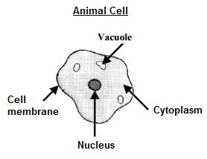

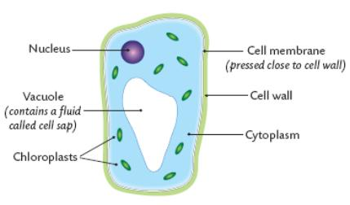
Video Animal & plant cells explained circa 5 minutes
What are the main differences between plant and animal cells?

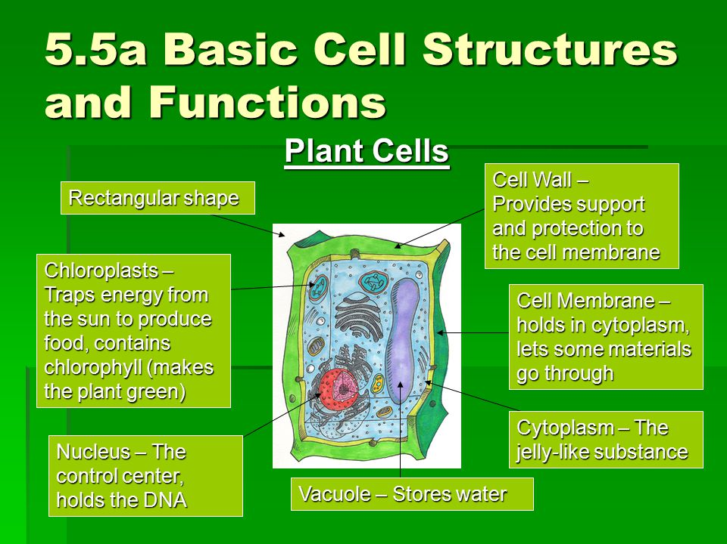

Investigate

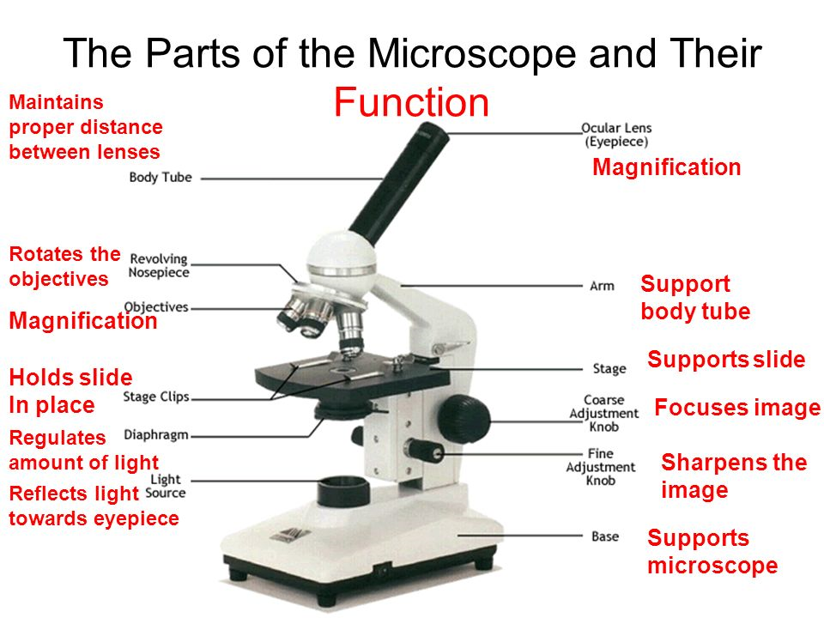

Video How the microscope works circa 1 minute

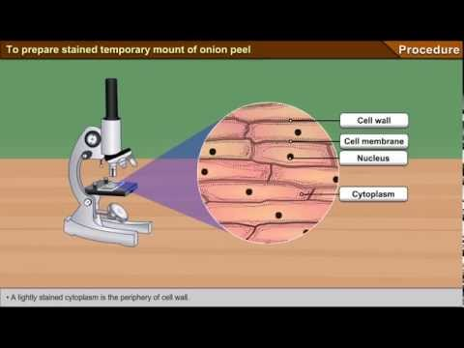
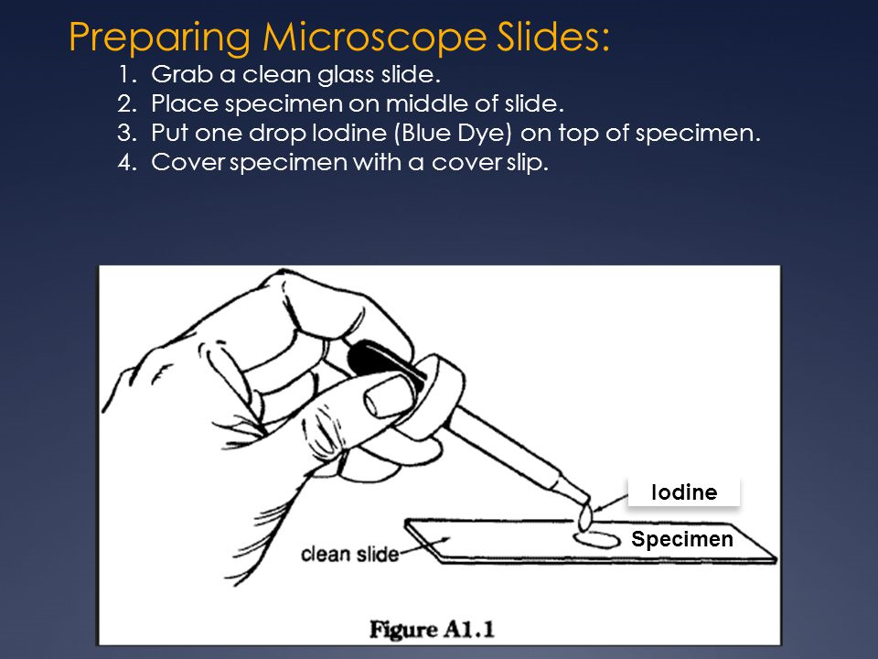

View of onion cells under the microscope (X100 Magnification)
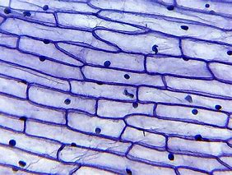

(2nd Year) Asexual & sexual reproduction. (Describe).(BW2)

(3rd Year) Photosynthesis & Factors effecting photosynthesis (Describe & Investigate) (plants also respire).(BW7)

<<Plant Reproduction.pptx>>click below

Video Plant reproduction circa 8 minutes

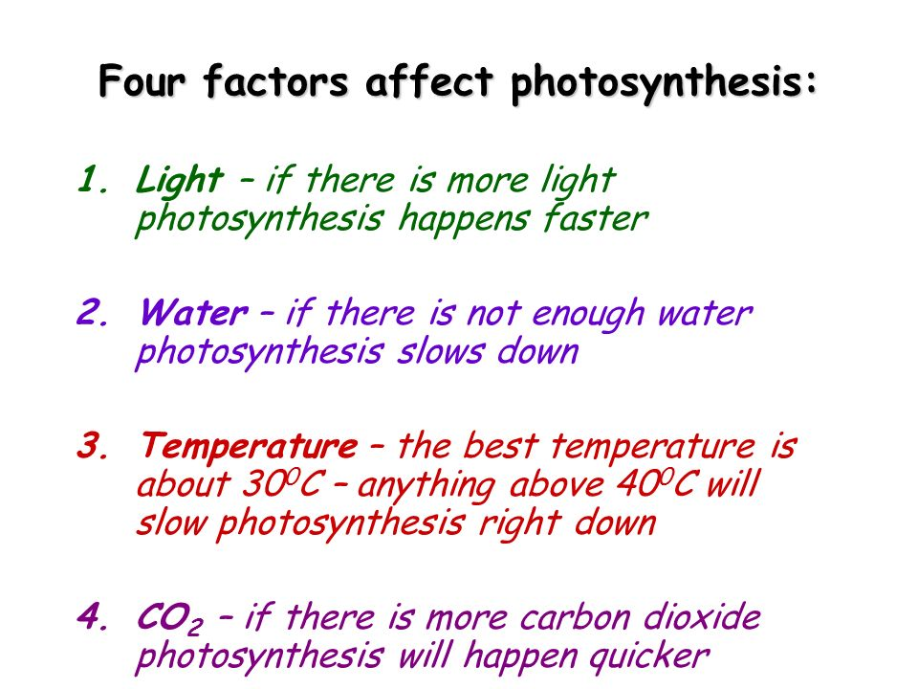

(Investigate) An Experiment to show how light intensity has an affect on the rate of photosynthesis.
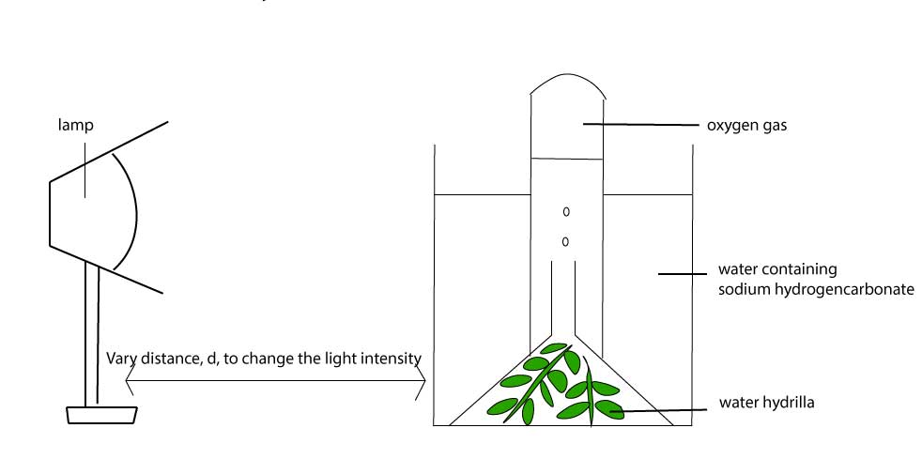

(2nd Year) Digestive system. (Describe).(BW4)

(2nd Year)Circulation system. (Describe).(BW4)

(2nd Year) Respiratory System. (Describe).(BW4)
(2nd Year) Respiration and the factors effecting.(Investigate)(BW7)

(3rd Year) Human Sexual Reproduction (Explain)(BW4).
& its medical, ethical & societal issues (discuss).(BW9)*

(3rd Year)Human health regarding inherited, environmental, Nutritional, & Life style choice factors (Evaluate)(BW6)(*more needed, food tests?)

(2nd Year) The role of micro-organisms in human health.(Examine)(BW6)

<<Digestion and Enzymes.pptx>>

Below are four power point presentations on the systems. Just click to view

Power point cut outs of digestive system (right click & hit presentation object & open: in powerpoint to print)

Pulse rate and respiration. (Exercise a factor that affects the rate of respiration)
(investigate)
The pulse rate is the amount of times your heart beats per minute.

At rest this is approximately 70 times per minute.

The heart rate increases if we exercise as more oxygen is needed by the body’s muscles.
When we exercise more energy is needed by the body and our rate of respiration increases.
Respiration is where the body combines food with oxygen to give us energy.
When exercising the heart rate increases to supply the oxygen needed for the increased rate of respiration.
Therefore exercising is a factor that affects the rate of respiration in our bodies.

Taking your pulse.
To check your pulse at your wrist, place two fingers between the bone and the tendon over your radial artery — which is located on the thumb side of your wrist. When you feel your pulse, count the number of beats in 15 seconds. Multiply this number by four to calculate your beats per minute.
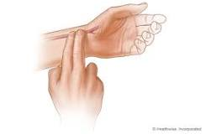
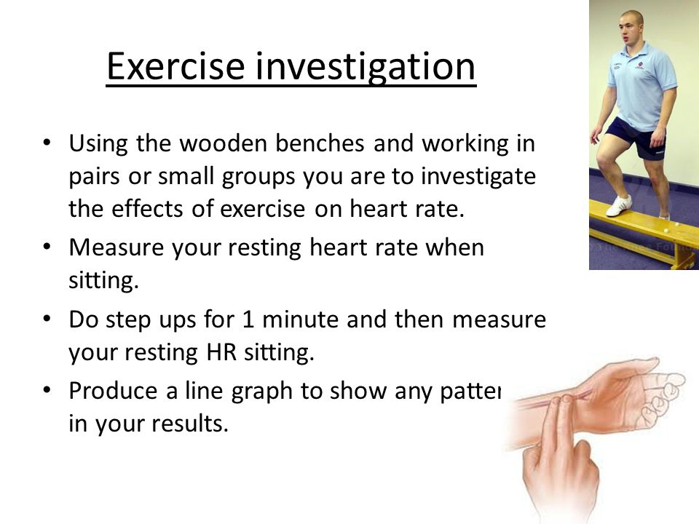
So Don't forget: Exercise causes increased heart and breathing rate because more oxygen is needed by the body due to an increase in the rate of respiration in the body.

Human Health:

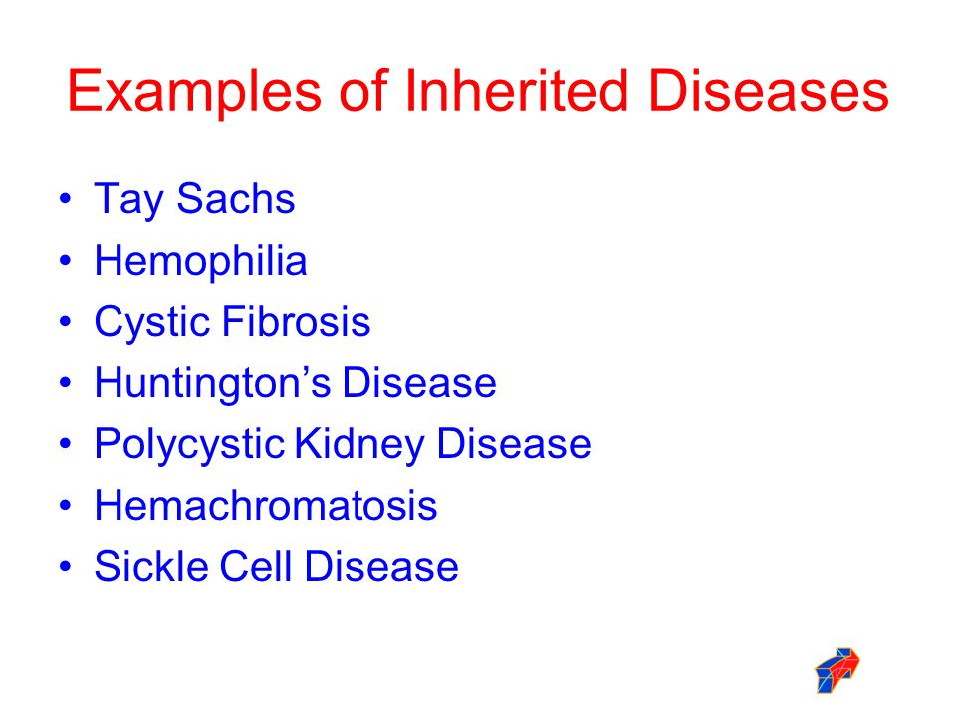
Find out more about these diseases, how they are transferred from one person to another and how they affect human health .

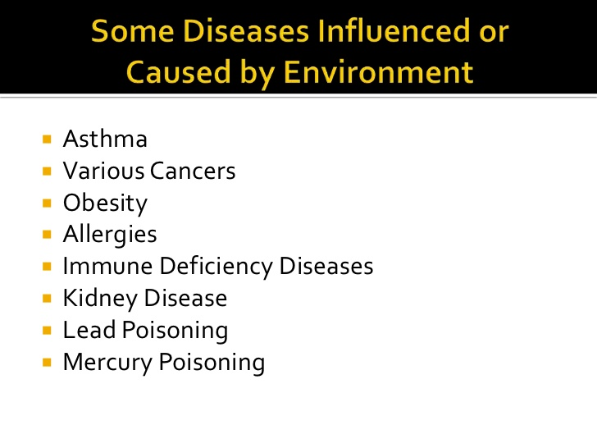
Find out more about these diseases, how people can contract them from their environment and how they affect human health.

Some Diseases caused by poor Nutrition (Diet)
- Heart Disease.
- Diabetes.
- Osteoporosis.
- Cancer.
- Obesity.

Find out more about these diseases, how they come about, how they can be prevented.

Lifestyle choices.
The lifestyles choices we make have a major effect on the health of our bodies

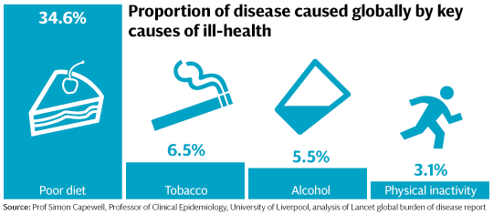

Micro Organisms & Human Health:

<<Microbiology and Biotechnology.pptx>>click

<<worksheet microbiology.docx>>
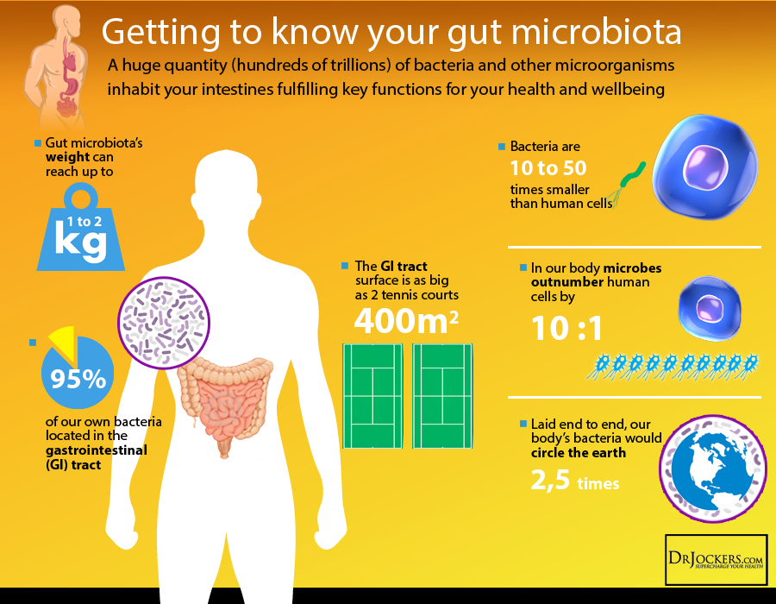

power point on microbes and disease Ctrl & Click

Micro Organismsvideo Ctrl & Click

Evolution by Natural selection. (Explain) (BW3).

(2nd year) Patterns of inheritance and variation of genetically controlled Characteristics (Explore) (BW2)

How natural selection explains diversity (Explain) (BW3).

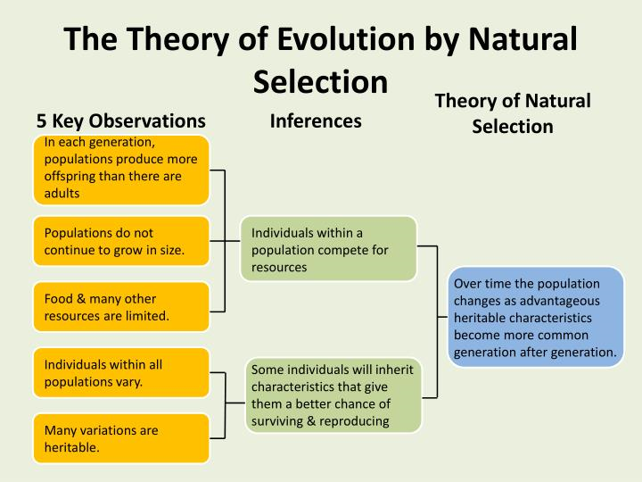

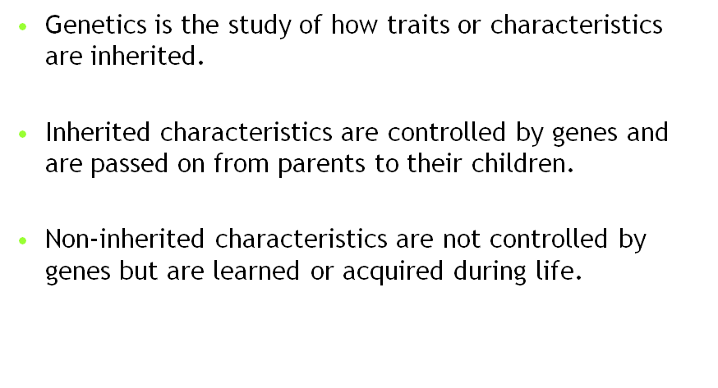
Chromosomes are located in the nucleus of a cell.
Chromosomes are made of DNA and protein.
Genes are located on chromosomes.

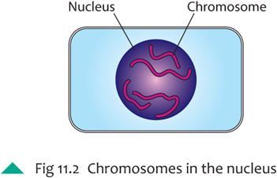
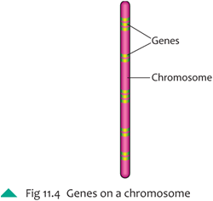

Genes are short sections of DNA which control the production of a protein.
Human cells have 46 chromosomes made up of two sets of 23 inherited from each parent.
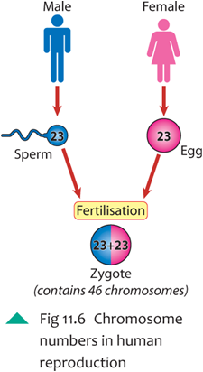

Explore: Patterns of inheritance and variation.(Part of plants too)

By carrying out a large number of experiments in the gardens of his monastery, Mendel discovered that several traits of pea plants follow simple inheritance patterns. This is when the appearance or absence of a trait is controlled by a single unit of inheritance, or gene.

He investigated the colour of the flowers of pea plants.
Pea plants can have purple or white flowers.
The gene that causes the purple flower is dominant.
The gene that causes the white flower is recessive.

Take a look below:
The B indicates the dominant purple flower gene.
The b indicates the recessive white flower gene.

We can see that even though both parent plants contain both dominant and recessive genes. The dominant gene of purple colour wins out over the recessive gene connected to white colour.
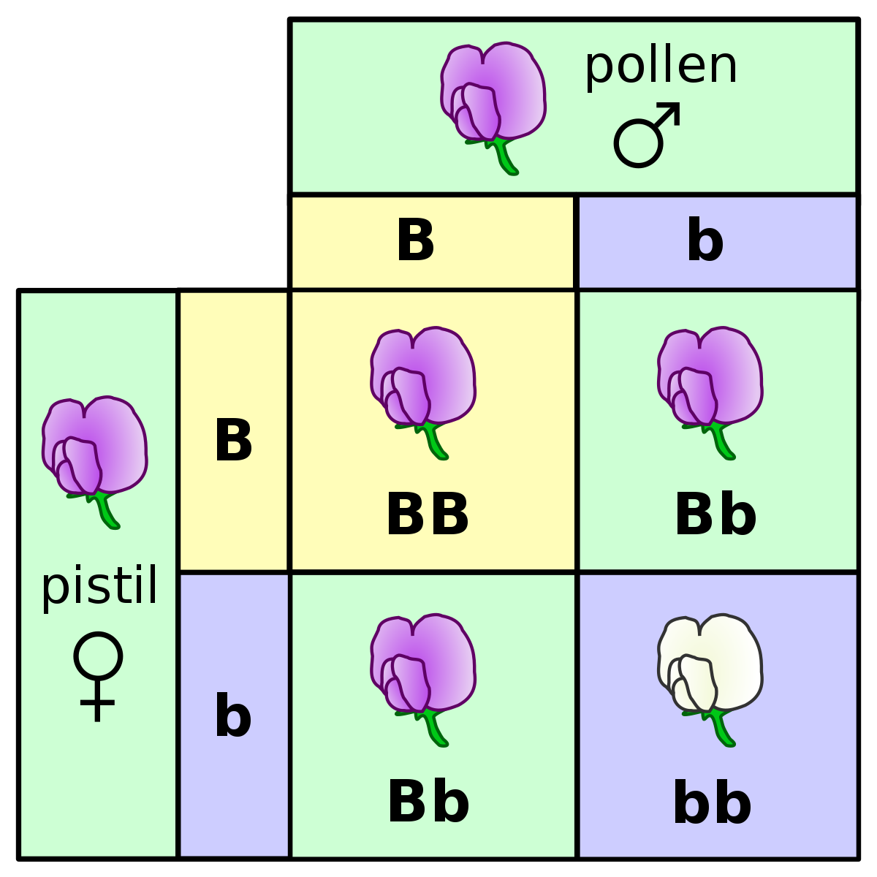

How Natural selection Explains Diversity:
Some examples:
Example 1:
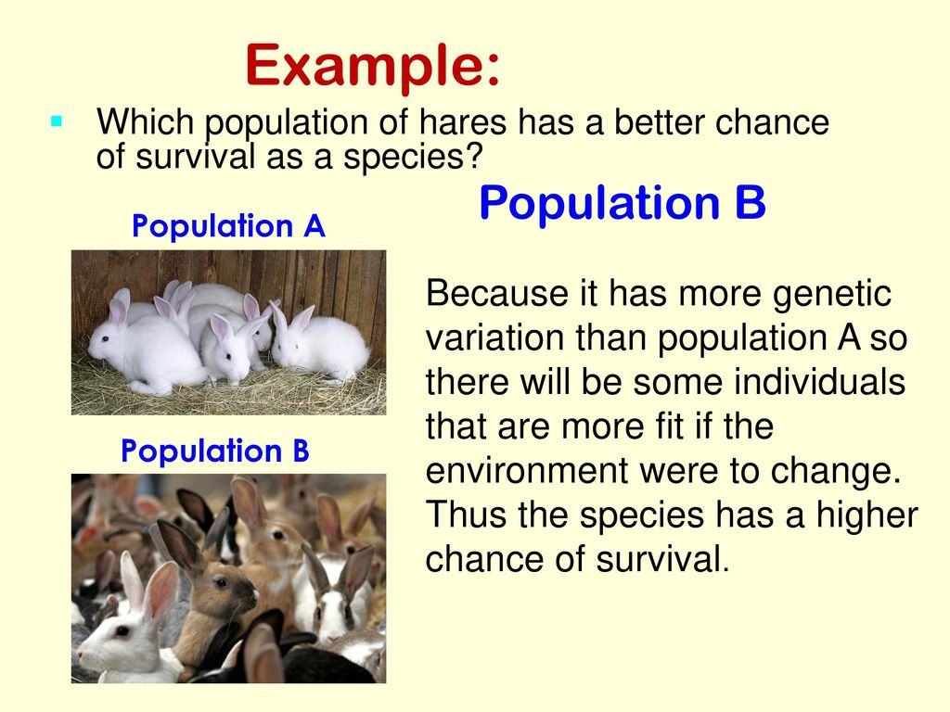
Example 2:
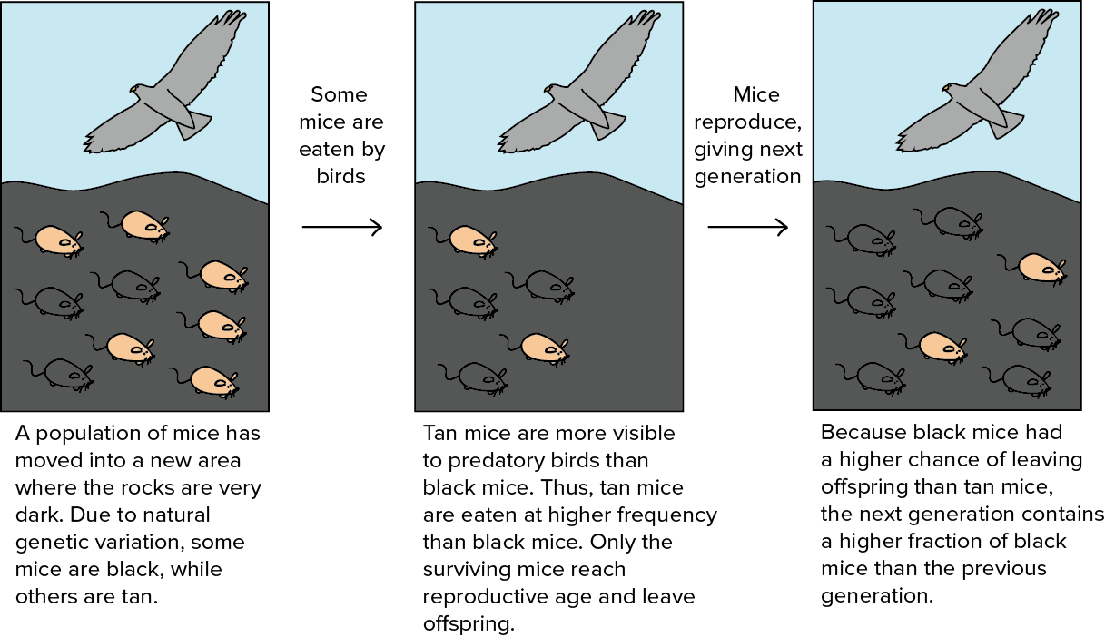
Example 3:
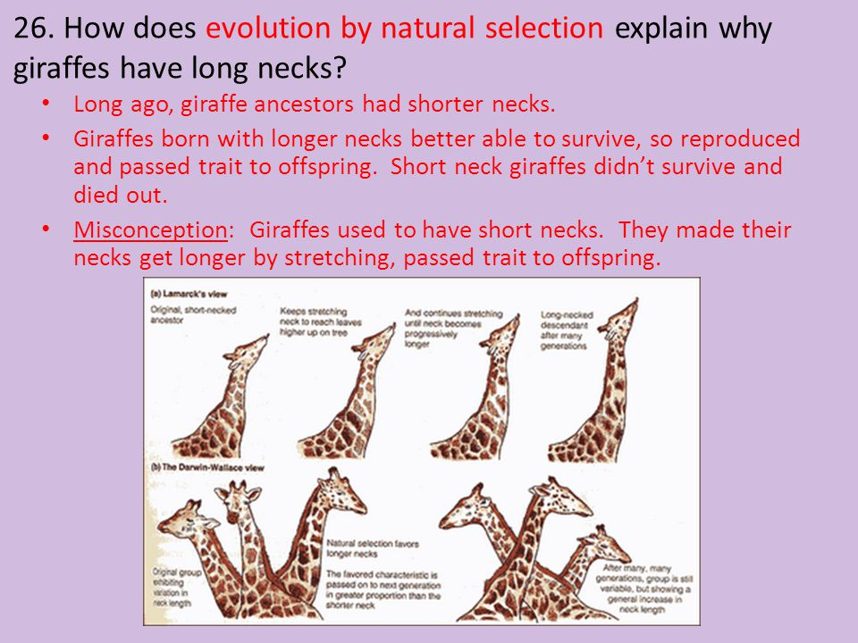

Video Natural selection + Fast Natural Selection and Evolution Circa 7.5 Minutes

Questions:
Q1. What is mean by fitness with regard to natural selection?
Q2. Explain in your own words how natural selection can cause the differences we see in living things.
Q3. What is meant by dominant and recessive genes?
Q4. DO some research to find an example of where natural selection has made a specific animal change over time. (Do not use any of the above examples)
Q5. What is meant by variation within a population?
Q6. After a particular trait becomes obvious within an animal population does this mean that there is no variation within that population? Explain your answer.

Carry out a Habitat Study.(Conduct)(BW5)

Understand Adaptation, Competition, Interdependence for specific habitats and communities. (Research, Investigate)(BW5)

How humans can Conserve biodiversity.(Evaluate)(BW10)*

Benefits of ecosystems to humans.(Evaluate)(BW10)

How humans can contribute to Global food production.(Evaluate)(BW10)

<<Ecology + habitat study.pptx>> click

(BW5).Research. Group work
Look at a woodland habitat and choose an animal that is well adapted to living in this habitat.

Woodland animals: Hedgehog, Rabbit, Deer, Badger, Squirrel.
Now imagine transferring the animal you picked into a mountain habitat.

Mountain animals: Sheep / Goat / Falcon / Hare.
Discuss how the animal would survive or not under the following headings:
Adaptation / Competition / Interdependence / Communities.

Video Wolf reintroduction to Yellowstone Biodiversity Circa 4.5 minutes

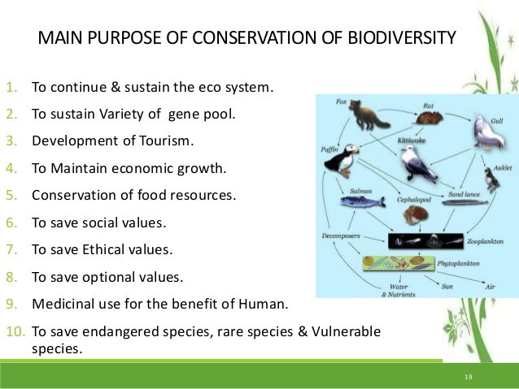

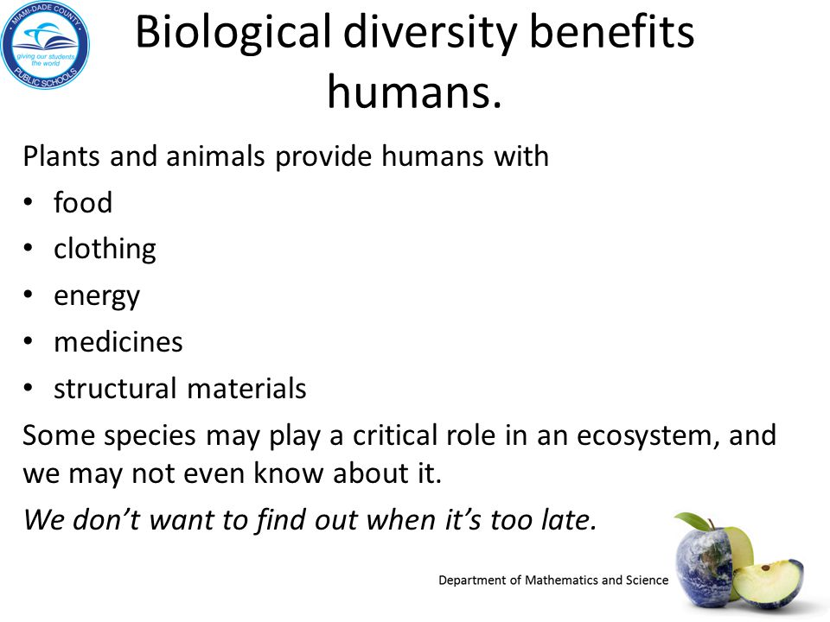

How Humans can conserve biodiversity on a Micro scale

Video Biodiversity Gardening circa 4 minutes

How Humans can conserve biodiversity on a Macro scale

The EU has a plan to conserve biodiversity.
Click on the link below to see what the EU plans:
EU plan for conservation of Biodiversity

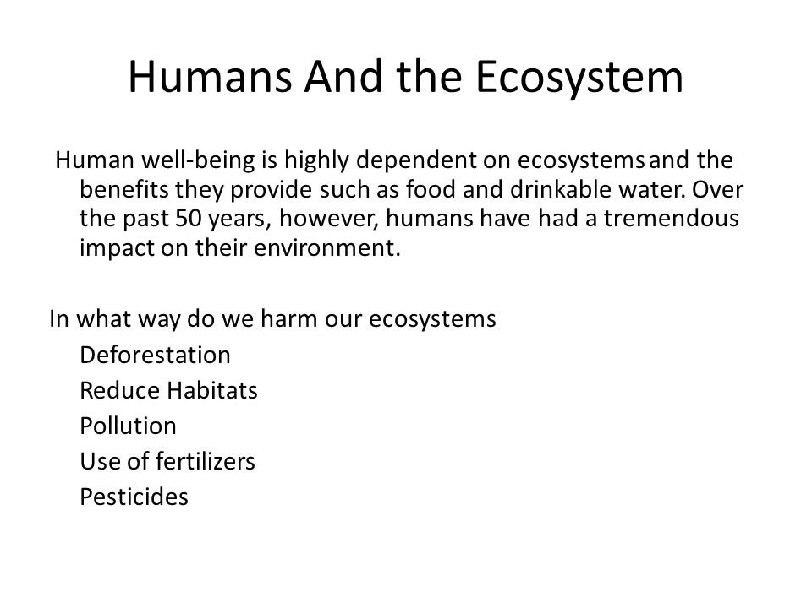
Evaluate:
Look above at the many ways in which humans harm the ecosystems in which we live.
Choose two ways from the list and evaluate the damage that has already been done.
Suggest some ways (realistic and sustainable) in which the damage could be reversed. Can you find examples of where this has been done already?

Most of the food produced globally comes from intensive farming methods.
Much of our food is highly processed before we purchase it.
There are advantages and disadvantages to having our food produced in this way
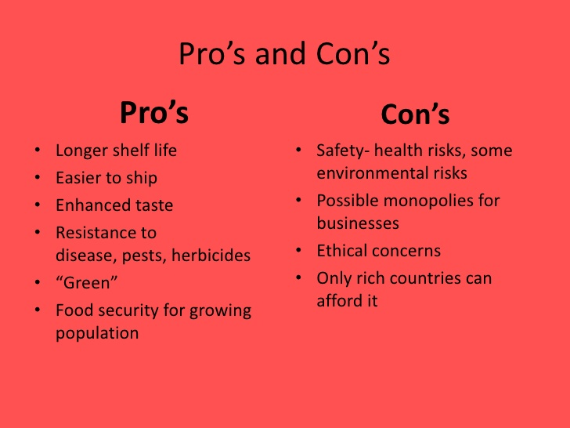

Humans can contribute to global food production in Macro and Micro ways:

Macro Human influence on global food production:
How can we contribute:

Information based on a study carried out by Paul C. West & the
Global Landscapes Initiative at the University of Minnesota

- Close the yield gap: This refers to the fact that in many poorer economic regions the amount of crops grown per Hectare is LESS than it could be.

- Use fertilizer more efficiently: The study found that the use of artificial fertilizers could be reduced dramatically worldwide and still yield the same amount of crops.

- Raise low water productivity: Plants that use less water to grow could be planted.

- Target food for direct consumption: Use land that is used to grow food for animals to grow food for humans.

- Reduce food waste: Eat the food that is grown and stop dumping it.

For more detail on these points click on the link below
5 ways to improve global food production and security

Use the link & points above to answer the questions below.
- Is the source of this study one you can be confident in? Give reasons for your answer.
- Identify difficulties which may be encountered if we tried to implement all five measures in a short space of time.
- Which measure do you think would be the easiest to implement and suggest ways you would go about doing so?

Group work: Look at the following two links to websites.
Both are talking about global food production.

Monstanto Homepage type: https://monsanto.com/
IISD Article type: IISD Bayer tightens control

Take notes from each.
Compare what both are saying.
Find out more about both online. (Don't forget to check the source)
Answer the following questions.

- What does Monstanto the company do in business?
- Who are IISD?
- List some of the products that Monsanto / Bayer sell.
- Do you think that these products are good for the environment? Explain.
- With regard to human health and global food production which group do you think is most interested in sustainable and natural food production? Give details in your answer.

Micro Human influence on global food production:
How can we contribute:

Growing your own food has many health benefits:
- It helps you eat more fresh fruits and vegetables.
- You decide what kinds of fertilizers and pesticides come in contact with your food.
- It lets you control when to harvest your food. Vegetables that ripen in the garden have more nutrients than some store-bought vegetables that must be picked early.
- It reduces the carbon footprint of you food.
- It uses land that would otherwise not be set aside for food production.

Click and read the two links below and then answer the questions that follow

SFGate on the disadvantages of growing your own food

Harvard Health Publishing on growing your own food

Questions:

- Find out more information about SFGate online.
- Find out more about who Harvard Health Publishing is online.
- Which source do you think is more reliable and why?
- Do you think the advantages outweigh the disadvantages of growing your own food?

Video Global food production and increasing plant biodiversity Circa 4.5 minutes

