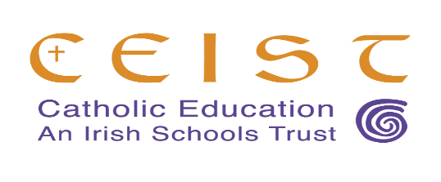
Note to Parents / Guardians of Meán Scoil Mhuire
RE: CONSULTATION ON THE FUTURE PROVISION OF CATHOLIC POST-PRIMARY EDUCATION IN LONGFORD

Tuesday 7th February 2023
As you are aware, St Mel’s College and Meán Scoil Mhuire have been at the forefront of the provision of high quality post-primary education in the Catholic tradition for many years in Longford
Both schools have a very rich historical tradition and are highly appreciated as providing a values based education to past and present students, alongside high academic standards.
Nationally, the educational landscape is changing rapidly, and it is the responsibility of the Patrons, as guardians of Catholic education in Longford, to consider the future and plan for future development of these great traditions.
Both Patrons (Diocese of Ardagh and Clonmacnois, and CEIST), have therefore agreed that it is an opportune time, in collaboration with each of the school communities, to explore together current and future Catholic secondary educational provision in Longford and surrounding areas.
A consultation process is now commencing which will seek to gather the views of boards of management, staff, students and parents, including primary school parents.
The Patrons have no predetermined outcome in mind, and wish to have an honest conversation with boards of management, staff, students and parents in both schools, and the parents of future post-primary students about the future of Catholic post-primary education provision in the area.
The views of local education partners will guide the Patrons in any future decisions.
This process will be guided by an independent facilitator, Mr. Frank Smith.
Mr. Smith will be in contact with you in the near future, through the school Principal, to consult with you on your views.
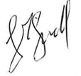
Gerry McGuill
CEO
CEIST

